**GIS Themes**

Two types of GIS themes will be available for this asset. Standard RAMS asset themes and custom themes based on the reports listed in the report section. Those themes will be mentioned in the report section of this document. The standard asset themes can be accessed in the Exor Spatial Manager Tool and can be found in the location with the other asset themes.

**RSD Reporting**

Several reporting objects are available for use with a report building tool. Some of the reports have a corresponding GIS version of them so that they can be used in Spatial Manager or another spatial tool of choice. The reports cover the following areas:

**Management Reports**

The management Reports are as follows:

**Defect During a period**

This reporting object is a standard oracle view with the name: x_rms_rsd_ddap. This view reports shows various defect information for a vendor. Several date fields are exposed that can be used to restrict that data over a selected period.

This report has a GIS counterpart with the name: x_rms_rsd_ddap_sdo. This counterpart view was designed to be viewed as a layer spatial manager.

**Inspections During a period**

This reporting object is a standard oracle view with the name: x_rms_rsd_idap. This view reports shows various inspection information for a vendor. Several date fields are exposed that can be used to restrict that data over a selected period.

This report has a GIS counterpart with the name x_rms_rsd_idap_sdo. This counterpart view was designed to be viewed as a layer spatial manager.

**Requests during a period**

This reporting object is a standard oracle view with the name: x_rms_rsd_rdap. This view reports shows various Requests information for a vendor. Several date fields are exposed that can be used to restrict that data over a selected period.

This report has a GIS counterpart with the name: x_rms_rsd_rdap_sdo. This counterpart view was designed to be viewed as a layer spatial manager.

**Accomplishments during a period**

This reporting object is a standard oracle view with the name: x_rms_rsd_adap. This view reports shows various Accomplishments information for a vendor. Several date fields are exposed that can be used to restrict that data over a selected period.

This report has a GIS counterpart with the name: x_rms_rsd_adap_sdo. This counterpart view was designed to be viewed as a layer spatial manager.

**3rd Party Service Provider Reports**

The Provider report is as follows:

**Performance During A Selected Period**

This reporting object is a non-standard oracle view with the name: x_rms_rsd_pdasp. This dashboard style report uses data from the Routine Services Data Defects section, the Requests section, the accomplishments section and the inspections section to determine several metrics.

To be able to achieve the dashboard like results a sys_context needed to be used. Before using this report the following commands should be issued form the report viewing software:

Note: MY_DATE is a text string in the format of ‘DD-MON-YYYY’ for example '01-JAN-1991'

XRMS_CONTEXT_RPT_DATES(‘START’, MY_DATE);

XRMS_CONTEXT_RPT_DATES(‘END’, MY_DATE);

If these context items are not set, then all the values are processed form '01-JAN-1901' to today.

Below is Sample data for a single provider:



**Post Installation Tasks**

* + 1. **Custom GIS Themes for use in Spatial Manger**

After installing the views open the GIS Layer Tool in RAMS open form GIS0020, GIS Layer tool

* Select Custom Layers
* Select Register a Table As Theme
* Fill in the following:
  + Base Table: x_rms_rsd_adap_sdo
  + Primary Key Field: OBJECTID
  + Geometry Field: GEOLOC
  + Geometry Type: 3302
  + Theme Name: ACCOMPLISHMENTS_PERIOD
* Click Register
* 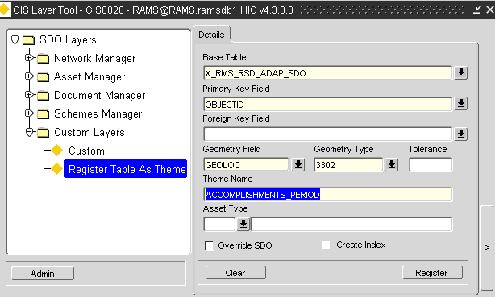
* Now Click on View Themes, this opens form GIS0010, GIS Themes
* Click on Roles
  + Add HIG_USER and Mode Normal
  + Others may be added if Roles are fine tuned
  + 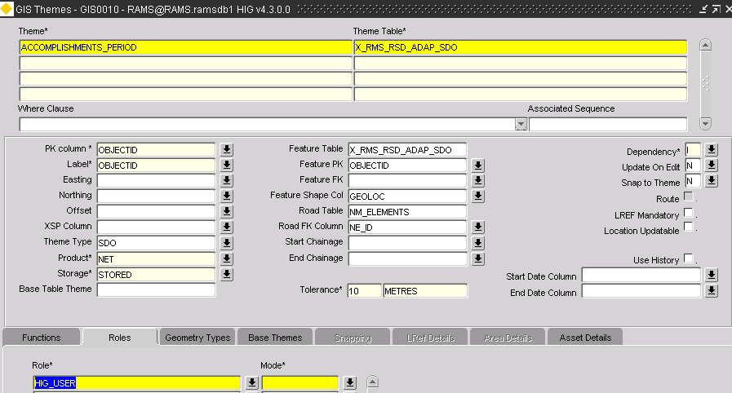

This Theme should now be available in Spatial Manager

Repeat the Process for:

* Defects during a period
* Inspections during a Period
* Requests during a period